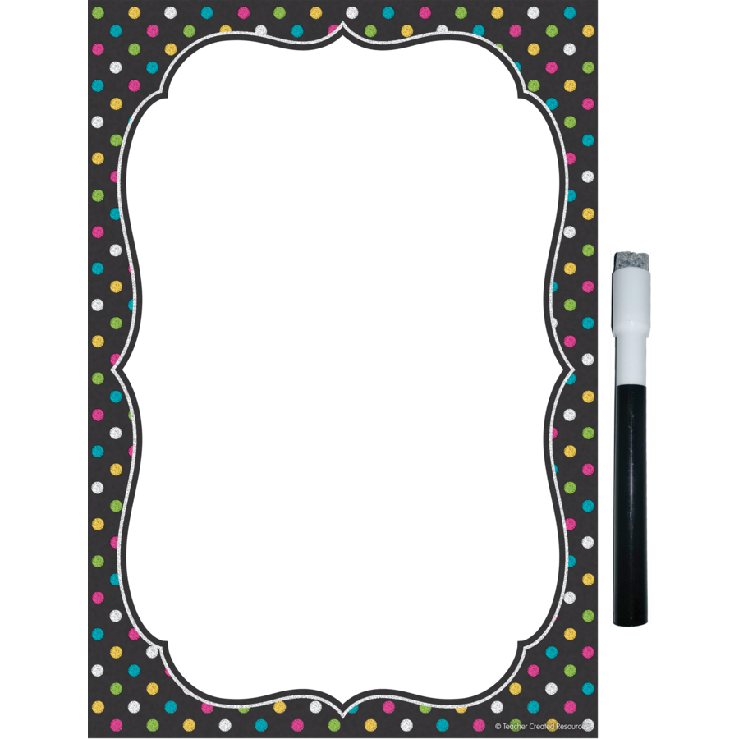 Dear Sixth Grader,

Summer 2025

Hello! I am Mrs. Keeler and I am SO excited to be your sixth grade teacher this year. I cannot wait to get started! We are going to make new friends, build a strong classroom community and challenge ourselves to achieve amazing things. Since this is your last year in Butler, we will make sure to make it the best year ever!

We will spend a lot of time in the beginning of the school year getting to know each other and forming meaningful relationships. Though before you come back to Butler for the first day of school, I wanted you to know a bit about me. Firstly, I LOVE teaching. This will be my tenth year teaching in Central Bucks, and my third year teaching sixth grade. I am proud to be a graduate of Penn State University, where I received my Bachelor of Science Degree in Education. I also have a Master of Education degree in Reading from Holy Family University. I love learning and hope to inspire the same love for education in our classroom this year.

I am excited to return to Butler this Fall since I took last year off to be home with my newborn son, Rhys. He will turn one on August 30th! I loved having the time to be home with Rhys, watching him learn and grow each day, as well as spending the year home with our dog, Willow. Being a Mom is my most important job, but I can’t wait to get back to teaching! My family and I took lots of trips to the beach this summer and enjoyed time on the Ocean City, NJ boardwalk. Also, you should know, I am a HUGE Penn State sports fan. I also love Philadelphia sports. You’ll hear me talking about the Nittany Lions, Eagles, Phillies, Flyers, Sixers and other sports teams all school year long!

I hope you are getting excited to be part of our sixth grade team this year! Since we are part of a team, every player is important for classroom success. We’ll work together to make this year amazing.

See you soon,

Mrs. Keeler